MOBILE APP FOR DONATING VIA YOUR SMARTPHONE
Go to either Google Play Store or Apple App Store and download the Vanco Mobile Faith Engagement app by Vanco Payment Solutions. Once downloaded, open the app on your phone.

Next search for St. John’s by name (easiest to search on Genoa and you will see St John’s United Church of Christ there) or by invite code FTFRF5
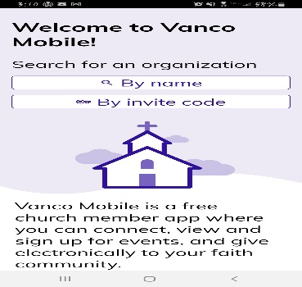
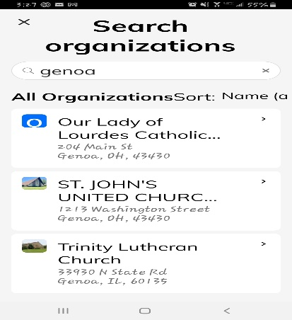
If searching by Genoa, this is what you will see. Select our church. If using the code, it will take you right there.
You will be able to at some point “create a login” that will save your information for future donations.
Once you’ve selected our church, this is what you’ll see.
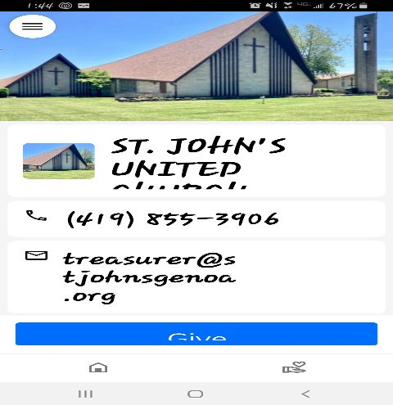
From here, you will select the blue button “GIVE” and this will appear where you will select which fund to give to: General Operating Fund, Christian Ed/Youth, or Missions/OCWM. If selecting Christian Ed/Youth/Missions/OCWM, you will be required to type in the memo field exactly what your gift is for. If giving to more than one funds, you can “add to basket” with each fund until the end.
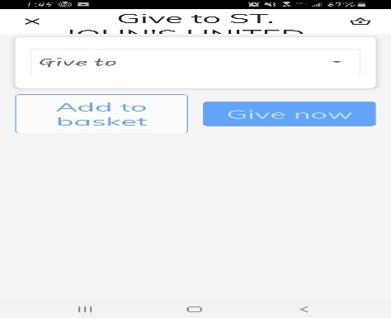
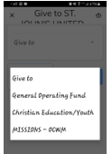
And then you can select the frequency …. example, a one time gift (Once, now), a future date, weekly, bi-weekly, monthly, etc.
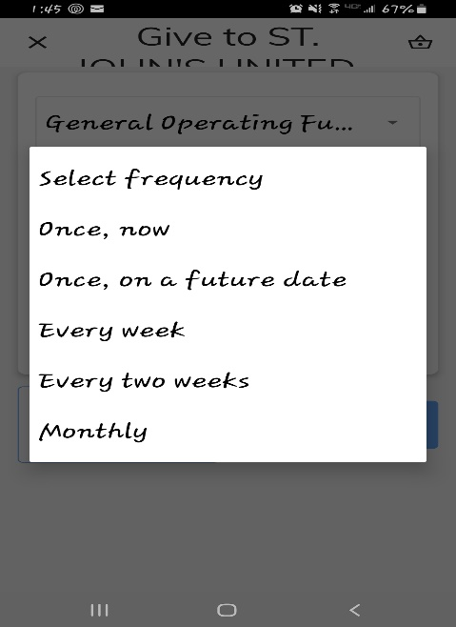
Once you have selected the above options and dollar amount (minimum $3), the next steps on your phone will be where you enter your banking or credit card info. It will also ask if you wish to cover the related fees charged to the church when donating (not required but helps the church). It will require you to enter your email, phone number, address and then finalize the payment. You will receive a confirmation of the payment in your email right away.
Any questions, please contact our church treasurer, Marsha Mihalko.

